**Konfigurasi VoIP**

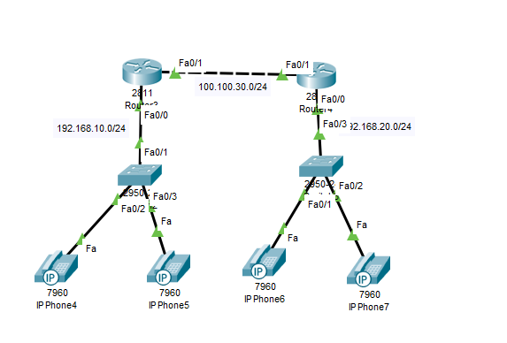

Router 1

Router>en

Router#conf t

Enter configuration commands, one per line. End with CNTL/Z.

Router(config)#ip dhcp pool voice

Router(dhcp-config)#net 192.168.10.0 255.255.255.0

Router(dhcp-config)#de

Router(dhcp-config)#default-router 192.168.10.1

Router(dhcp-config)#op

Router(dhcp-config)#option 150 ip 192.168.10.1

Router(dhcp-config)#ex

Router(config)#ip dhcp ex

Router(config)#ip dhcp excluded-address 192.168.10.1

Router(config)#int fa0/0

Router(config-if)#ip add 192.168.10.2 255.255.255.0

Router(config-if)#no sh

Router(config-if)#

%LINK-5-CHANGED: Interface FastEthernet0/0, changed state to up

%LINEPROTO-5-UPDOWN: Line protocol on Interface FastEthernet0/0, changed state to up

Router(config-if)#ex

Router(config)#te

Router(config)#telephony-service

Router(config-telephony)#max-e

Router(config-telephony)#max-ephones 2

Router(config-telephony)#max-dn 2

Router(config-telephony)#ip sou

Router(config-telephony)#ip source-address 192.168.10.1 port 2000

Router(config-telephony)#auto ass

Router(config-telephony)#auto assign 2 to 4

Router(config-telephony)#ex

Router(config)#ephone-dn 1

Router(config-ephone-dn)#%LINK-3-UPDOWN: Interface ephone_dsp DN 1.1, changed state to up

Router(config-ephone-dn)#num 1001

Router(config-ephone-dn)#ex

Router(config)#ephone-dn 2

Router(config-ephone-dn)#%LINK-3-UPDOWN: Interface ephone_dsp DN 2.1, changed state to up

Router(config-ephone-dn)#num 1002

Router(config-ephone-dn)#ex

Router(config)#int fa0/1

Router(config-if)#ip add 100.100.30.1 255.255.255.0

Router(config-if)#no sh

Router(config-if)#

%LINK-5-CHANGED: Interface FastEthernet0/1, changed state to up

%LINEPROTO-5-UPDOWN: Line protocol on Interface FastEthernet0/1, changed state to up

ex

Router(config)#dial-peer voice 1 voip

Router(config-dial-peer)#ses

Router(config-dial-peer)#session t

Router(config-dial-peer)#session target ipv4:100.100.30.2

Router(config-dial-peer)#des

Router(config-dial-peer)#destination-pattern 10..

Router(config-dial-peer)#ex

Router 2

Router>en

Router#conf t

Enter configuration commands, one per line. End with CNTL/Z.

Router(config)#ip dhcp pool voice

Router(dhcp-config)#net 192.168.20.0 255.255.255.0

Router(dhcp-config)#de

Router(dhcp-config)#default-router 192.168.20.1

Router(dhcp-config)#op

Router(dhcp-config)#option 150 ip 192.168.20.1

Router(dhcp-config)#ex

Router(config)#ip dhcp ex

Router(config)#ip dhcp excluded-address 192.168.20.1

Router(config)#int fa0/0

Router(config-if)#ip add 192.168.20.1 255.255.255.0

Router(config-if)#no sh

Router(config-if)#

%LINK-5-CHANGED: Interface FastEthernet0/0, changed state to up

%LINEPROTO-5-UPDOWN: Line protocol on Interface FastEthernet0/0, changed state to up

Router(config-if)#ex

Router(config)#te

Router(config)#telephony-service

Router(config-telephony)#max-e

Router(config-telephony)#max-dn 2

Router(config-telephony)#ip sou

Router(config-telephony)#ip source-address 192.168.20.1 port 2000

Router(config-telephony)#auto ass

Router(config-telephony)#auto assign 1 to 2

Router(config-telephony)#ex

Router(config)#ephone-dn 1

Router(config-ephone-dn)#%LINK-3-UPDOWN: Interface ephone_dsp DN 1.1, changed state to up

Router(config-ephone-dn)#num 2001

Router(config-ephone-dn)#ex

Router(config)#ephone-dn 2

Router(config-ephone-dn)#%LINK-3-UPDOWN: Interface ephone_dsp DN 2.1, changed state to up

Router(config-ephone-dn)#num 2002

Router(config-ephone-dn)#ex

Router(config)#int fa0/1

Router(config-if)#ip add 100.100.30.2 255.255.255.0

Router(config-if)#no sh

Router(config-if)#

%LINK-5-CHANGED: Interface FastEthernet0/1, changed state to up

Router(config-if)#ex

Router(config)#

%LINEPROTO-5-UPDOWN: Line protocol on Interface FastEthernet0/1, changed state to up

Router(config)#dia

Router(config)#dial-peer v

Router(config)#dial-peer voice 2 voip

Router(config-dial-peer)#ses

Router(config-dial-peer)#session t

Router(config-dial-peer)#session target ipv4:100.100.20.1

Router(config-dial-peer)#de

Router(config-dial-peer)#destination-pattern 2..

Router(config-dial-peer)#

Router(config-dial-peer)#ex

Router(config)#

**Baca dan perhatikan konfigurasi VoIP diatas, terdapat beberapa kesalahan syntax yang membuat rangkaian VoIP tidak dapat berkomunikasi antar Client. Buat kembali konfigurasi yang benar sesuai dengan topologi yang sudah ditentukan diatas, beri tanda “BOLD” pada konfigurasi yang kurang/salah. Konfigurasi bisa dikumpulkan melalui catatan di buku namun lebih disukai dalam bentuk Word/.pkt. Selamat Mengerjakan ☺**